*Name: __Chet-Yeng Loong________________
*Grade Level: Grade K
Musical Concept: Fast and slow

*State Core Music Standards:
Core Music Standards:
Cr. 1.1, Cr. 2.1, Cr. 1.1
Pr. 4.2, Pr - 4.2 (A,B) /
Pr 4.1: Performing: Present:
- Perform expressively, with appropriate interpretation and technical accuracy, and in a manner appropriate to the audience and context.
Pr 4.3: Performing: Interpret:
- Develop personal interpretations that consider creators' intent.
Pr 5.1: Performing: Rehearse, Evaluate, and Refine:
- Evaluate and refine personal and ensemble performances, individually or in collaboration with others.
Pr 6.1: Performing: Present:
- Perform expressively, with appropriate interpretation and technical accuracy, and in a manner appropriate to the audience and context.
Re - 7.2 / 8.1
8.1:Responding: Interpret:
- Support interpretations of musical works that reflect creators'/performers' expressive intent.
Cn - 10.0
11.0: Connecting: Connect #11:
- Relate musical ideas and works with varied context to deepen understanding.

*Prerequisites:

Prerequisites:
- Steady beat, Steady beat
- fast and slow
- using singing voice
Steady beat
Sing in head voice (high so)

Objectives/outcome:
Students will be able to:
- Sing the song with head voice, with accurate pronunciation, pitch and rhythm and motions.
- Sing from slow to fast tempo.
- Describe the song and its culture of origin

Procedures:
Sequence/Time | Activity | Procedures | Materials
Day 1 – Pre-prepare | Tong Tong Tong | - Explain the background of the song to the children.  - This is a Filipino song, and the language is Visayan, which is commonly spoken on the islands in the middle of the Philippines.  - The song is about catching crab.  *****************************************  Tong Tong Tong Tong Pakitongkitong  nonsense words  Alimango, sa suba  This huge crab is so huge, it is so hard to catch it  gibantog nga dili makuha  I hope I will be the one to get it  Ako ray makakuha , ako ray makasula  I wish I will be the one to trap it  **********************************************  - Ask students how do crabs walk? To the front? To the back? To the side?  - Teach the kids phrase by phrase by imitating the motion of a crab moving.  - Students do not sing, just imitate the motions.
Day 2 |  | - Day 2, review all the motions  - Show the lyrics on the SMARTboard file, and teach children sing phrase by phrase.  - Sing the whole song with motions  - Add tempo, starting from slow to fast.  - Cue the students when it is the last round.  - Watch the below link:  https://www.youtube.com/watch?v=eCu8Fu1h4VQ  - Ask comments from students. How is their performance different from the above video.  - What do they like? What do they value?  Introduce to children there are many famous choral groups (ensembles) in the Philippines. | SMARTboard

Tong tong tong tong
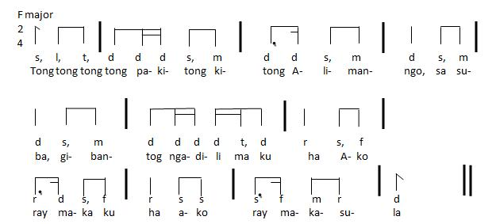

Tong Tong Tong Tong Pakitongkitong
This huge crab is so huge, it is so hard to catch it
I hope I will be the one to get it, I wish I will be the one to trap it

https://vimeo.com/user18507948/review/141000236/d1c87a023a
Assessment – we will discuss this on Oct. 3.

Teacher’s reflection/talk:

CHART 1a - Singing
4 | 4 = student sang the entire song with head voice, 1 inaccurate pitch/interval and rhythm precise pitches, appropriate tempo, and excellent posture.
3 | 3 = student began on correct starting pitch, sang with head voice, 1-3 inaccurate pitch/interval and rhythm, good tempo, and appropriate posture.
2 | 2 = student did not start on the correct pitch, sang without head voice, with 4—5 incorrect pitches and rhythm, inconsistent effort in demonstrating tempo, and poor posture.
1 | 1 = student did not use head voice, sang without tonal center, no evidence in demonstrating tempo, and poor posture.

