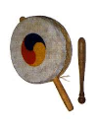*Name: __Chet-Yeng Loong________________

**\*Grade Level: Grade 1**

**Concepts: Steady Beats, Rhythm**

*State Core Music Standards:

For example: Cr1.1, Cr 2.1, Cr. 3.1., 3.2, copy and paste the standard(s) here:

**Cr 2.1: Creating: Present**

* Share creative musical work that conveys intent, demonstrates craftsmanship, and exhibits originality.

**Pr 4.2: Performing: Analyze**

* Analyze the structure and context of varied musical works and their implications for performances.

**Pr 5.1: Performing: Rehearse, Evaluate, and Refine**

* Evaluate and refine personal and ensemble performances, individually or in collaboration with others.

**Pr 6.1: Performing: Present**

* Perform expressively, with appropriate interpretation and technical accuracy, and in a manner appropriate to the audience and context.

~~Pr. 7.1, Re. Re - 7.2 / 8.1 /~~

**9.1: Responding: Evaluate**

* Support evaluations of musical works and performances based on analysis, interpretation, and established criteria.

**11.0: Connecting: Connect #11**

* Relate musical ideas and works with varied context to deepen understanding.

*Prerequisites:

* Steady beat
* Auditory rhythmic proficiency
* Proper use of hand drum (with both hands and with stick)
* Counting up to four/counting four-beat patterns
* Know left and right, Ability to mirror movements

*Objectives/Outcomes:

Students will be able to:

1. Move to steady beat, perform sequence of rhythms

2. Demonstrating a sense of internal pulse through movement

3. Demonstrating locomotor and non-locomotor skills

4. Describe and perform Korean drum dances

5. Distinguish their performance and performances that performed by Korean children through videos

*Procedures:

|  |  |  |  |
| --- | --- | --- | --- |
| **Sequence/Time** | **Activity** | **Procedures** | **Materials** |
| Day 1 | Korean Drum | 1. Explain the background of the Korean sogo drum dance to the children.   소고 – sogo, Korean small drum  춤추기- dance  <http://www.koreamusic.org/LangEn/TextDetailView.aspx?MenuCode=204010321>   1. Ask the children to stand in rows, teach the following motions.  * Hit the drum - Draw a circle from the bottom to the top * Hit the drum - Open arms - Cross arms - Parallel to body * Hit the drum - Sway right - Sway left - Sway right * Hit the drum (waist level) - Hit the drum with elbow - Hit the drum (waist level) -Hit the drum with elbow * Hit the drum in front of the body while hopping - Hit the drum at the back while hopping * Hit the drum - Lift arms up - Go down - Hit the floor * Hit the drum - Right/Left arm up & left /right arm down -Keep bouncing * Running and hitting the frame with fast tempo   Seven different motions. Each one repeat 4 times   1. Ask comments from students. How is their performance different from the Korean kids and Big Kids? H  * <https://www.youtube.com/watch?v=eCu8Fu1h4VQ> * <https://www.youtube.com/watch?v=mkflmVI7R9M>  1. Introduce to children the Korean traditional costumes. Hanbok? 한복.   <https://en.m.wikipedia.org/wiki/Hanbok> |  |

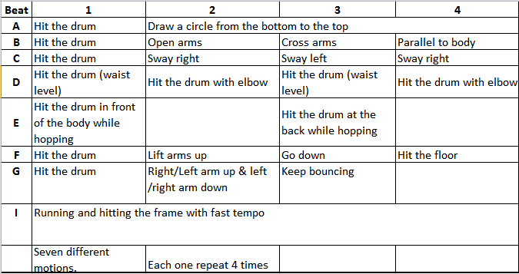

<https://vimeo.com/user18507948/review/141000236/d1c87a023a>

Teacher’s reflection/talk:

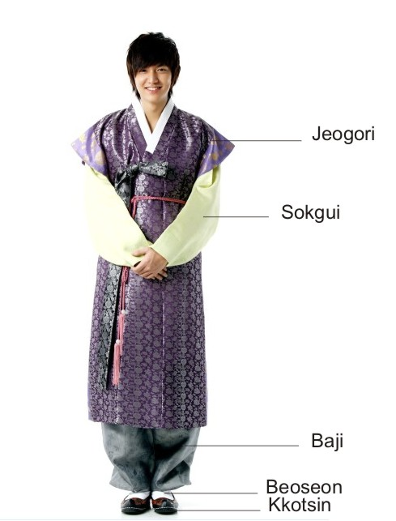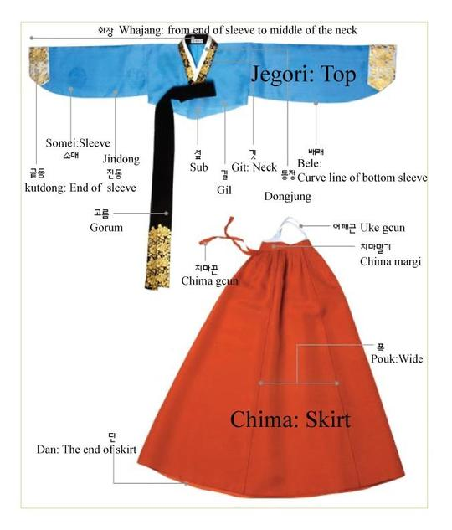

Assessment:

4 = student played Korean drum and performed drumming rhythmic patterns accurately throughout the song/chant

3 = student played Korean drum and performed drumming rhythmic patterns with 80% - 99% accuracy (1 to 3 mistakes)

2 = student played Korean drum and performed drumming rhythmic patterns with 60% - 79% accuracy (4 to 6 mistakes)

1 = student played Korean drum and performed drumming rhythmic patterns with 40% - 59% accuracy (7 to 10 mistakes)

0 = student could not play Korean drum or perform drumming rhythmic patterns accurately throughout the song/chant

??

What do they like? What do you value?