Dalcroze:
- Can you do split the screen? Actually, the bottom image is more important, right?
- I strongly encourage you to use a metronome to help you keep the steady beat; you were rushing.
- It would be best if you played more expressively. When you play ti-ti, accent the first sound, don’t make the notes sound equal. For ta note, why played the same note, I don’t understand.
- Suggestion: Take two xylophones:
  - BX: For Ta-a, ta
  - SX: For ti-ti, this will make your improvisation more “colorful.”
  - Change to a soft mallet.
- You modeled well with ta-a pattern. Do the same with ta and titi.
- Aiyo, you played faster and faster, use a metronome.

Alligator Pie:
Suggestions:
- Make your voice and facial expression more animated in order to attract the students’ attention.
- When you wanted to make sure the students are able to tap “alligator,” you need to slow down the tempo.
- “How many sounds does alligator have?” You asked this same question multiple times.
- You spoke the rhythm for the students most of the time. When are you going them time to do it by themselves? For example:
- 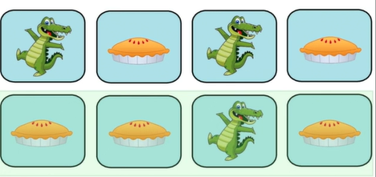
- When there is “alligator,” don’t say the word, ask the students to speak it, you just need to move your mouth. You did most of the work for the students.
- Very good visual aids, nicely done.

