*Name: Chet-Yeng Loong
*Grade Level: Gr 1
*State Core Music Standards (draft):
For example: Cr1.1, Cr 2.1, Cr. 3.1., 3.2, copy and paste the standard(s) here:

Figure out yourself

*Prerequisites:
So-mi

*Objectives/Outcomes (no more than five) – for example, artistic skills/knowledge/contextual learning:

Students will be able to:
- Sing “roll over” correctly.

*Procedures:
Sequence/Time | Activity | Procedures | Materials
Day 1 | Ten in the Bed | - Sing “Ten in the Bed” to the children.  - Teach children to echo “Roll over, roll over”.  - Start from number 10, sing the entire song, children echo “Roll over.”  - Assess individual singing.

Day 2 | Ten in the Bed | - Take out step bells.  - Play “C’-A-F” on the bells.  - Ask the children play and sing “Roll over” individually.  - Ask children the bells are steps or skips apart (skips).  - Show SMARTboard file.  - Relate the bells, show children three notes on the board are also skipped apart.  - Ask children what is the solfege of the note in the 3rd space (so); and 2nd space (mi).  - Ask children where is the new note, which space? (first)  - Show children the hand signs of “do”, but do not tell them the solfege.  - Sing the whole song. This time, ask children echo “so-mi-hmm” (hum the new note).  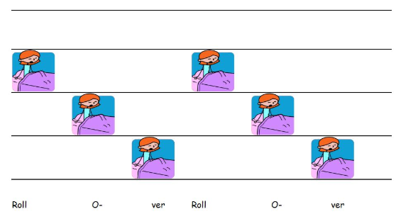 | SMARTboard
Assessment:

Rubric for assessing echo singing
Exceeds Target = 4 | Meets Target = 3 | Approaching Target = 2 | Well Below Target = 1
Student echo sang the four-beat melodic response with precise pitches throughout. | Student echo sang the four-beat melodic response starting on the correct pitch, but did not sing correct pitches throughout. | Student did not start on the correct starting pitch; either sang too high or too low as indicated by an arrow up or an arrow down. | Student did not start on the given starting pitch, or student did not use a singing voice.

Teacher’s reflection/talk:

??

