**\*Name**: Cathlyn Momohara

**\*Grade Level**: Grade 4

**\*State Core Music Standards (draft):**

Pr 4.2: Performing: Analyze

Analyze the structure and context of varied musical works and their implications for performance.

Pr 4.3: Preforming: Interpret

Develop personal interpretations that consider creators’ intent.

Pr 5.1: Performing: Rehearse, Evaluate, and Refine

Evaluate and refine personal and ensemble performances, individually or in collaboration with others.

Pr. 6.1: Performing: Present

Perform expressively, with appropriate interpretation and technical accuracy, and in a manner appropriate to the audience and context.

Re 9.1: Responding: Evaluate

Support evaluations of musical works and performances based on analysis, interpretation and established criteria.

Cn 11.0: Connecting: Connect #11

Relate musical ideas and works with varied context to deepen understanding.

**Prerequisites: Students are able to:**

* Vocal range: C4-E5
* Read do pentatonic on the staff
* Play dotted eighth and sixteenth notes (tim-ri) and ti-tiri, 4/4 meter
* Read half note, quarter note, and eighth note rhythms
* Perform articulations within a song (e.g. staccato, tenuto)

**\*Objectives/Outcomes:**

At the end of the lesson, the students are able to:

1. Explain the translation of “Shojoji.
2. Sing “Shojoji” with technical accuracy and expression.
3. Sing “Shojoji” while maintaining a simple rhythmic ostinato with body percussion (stomps and snaps) and hand drums.
4. 4.Notate an 8-beat ostinato rhythm.Create motions with a partner to perform an ostinato rhythm with a hand drum.
5. Perform “Shojoji” with a sung melody and two complementary ostinati (performed with bass xylophones and hand drums).

**\*Procedures:**

|  |  |  |  |
| --- | --- | --- | --- |
| **Sequence/Time** | **Activity** | **Procedures** | **Materials** |
| Day 1 | Learning the folk song with motions | * T models the song and motions for the students. * T asks S to interpret what the song could mean based on the motions. * S pair-share with their neighbor what they believe the song about. * T ask Japanese natives if they can translate the song. * T explains the translation of the song. * T asks students can describe some of the elements of the song. * S learn the motions through echo imitation. * Line 1: temple * Line 2: moon, come (palms down) * Line 3: calling friends, drum on stomach * T displays Romanji on the board. * S identify where the words are sung staccato and tenuto. * S sing song with articulation markings. * T asks S to sing song without noticeable articulations. * T asks S what the difference is between singing with and without articulations (e.g. mood, expression, vocal comfort) | Chart 1 – Romanji on the white board  Chart 2 – T only |
| Day 2 | Practice “Shojoji” with the steady beat ostinato. | * S review song with motions. * S identify “do”” in C major and read/sing the 1st and 3rd line of the song slowly with solfege. *It is in C pentatonic scale: Do- re- mi- so- la- do’* * S sing entire song independent of T. * T begins to model the sticking pattern of the xylophone ostinato as S sing.      * S learn through simultaneous imitation. * S sing song as they mirror the sticking pattern. * S pair and go to an Orff instrument. * S set up Orff instrument in C Pentatonic. * S practice playing ostinato pattern with C and G. * S playing Orff instruments will repeat the ostinato 2x. S will begin to sing after the 8-beat introduction. S playing will end the song by repeating the ostinato 2x. * Have D switch roles until all S have played the ostinato. | Chart 3  Chart 4-T only  Orff instruments (whatever T has available) |
| Day 3 | Perform the full arrangement. | * S review the song while patting the steady beat ostinato sticking pattern. * T models the hand drum ostinato while clapping and saying the text.      * S learn through simultaneous imitation. * S notate the rhythm of this ostinato on the white board. T helps to re-establish the steady beat. * S read notated rhythm with rhythmic syllables. * S work with a partner to create funny (but safe) motions to play the ostinato on a hand drum. * ½ of S perform ostinato 4x with partner as the other S observe. Share “I noticed/valued/wondered statements.” * Switch. Share observations. * T helps S decide how the class will perform this ostinato pattern. * Class practices funny motions. * T splits class into 3 groups. 1st group will sing, 2nd group will play the bass xylophone (steady beat ostinato), and 3rd group will play the hand drum ostinato. * *Form: 8-beat intro from bass xy/voices & hand drums perform song 2x/8-beat ending from bass xy* * S rotate parts until everyone has performed each part of the arrangement. | Chart 5  Hand drums  Bass xylophones |

*Assessments

**General Singing**

|  |  |  |  |
| --- | --- | --- | --- |
| **ME = 4** | **MP = 3** | **DP = 2** | **WB = 1** |
| * Entire song with head voice * 0-1 error * Precise pitches * Accurate rhythm * Appropriate and consistent tempo * Excellent posture | * Began on correct starting pitch * Used head voice * 2-3 errors * Good tempo * Appropriate posture | * Did not start on correct pitch * Sang without head voice * 4-5 errors * Inconsistent tempo * Poor posture | * Did not use head voice * No tonal center * No tempo established * Poor posture |

**Phrasing**

|  |  |  |  |
| --- | --- | --- | --- |
| **ME = 4** | **MP = 3** | **DP = 2** | **WB = 1** |
| * Consistently sang with appropriate phrasing, expression, and tempo | * Usually sang with appropriate phrasing, expression, and tempo | * Inconsistently demonstrated phrasing or expression | * Rarely demonstrated phrasing or expression |

**Chanting or singing Ostinato**

|  |  |  |  |
| --- | --- | --- | --- |
| **ME = 4** | **MP = 3** | **DP = 2** | **WB = 1** |
| * Precise pitches * Accurate rhythm * Appropriate and consistent tempo * 0-1 error | * Began on correct starting pitch * 2-3 errors * Good tempo | * Did not start on correct pitch * 4-5 errors * Inconsistent tempo | * Did not use head voice * No tonal center * No tempo established |

**Multipart Rhythmic Performance**

|  |  |  |  |
| --- | --- | --- | --- |
| **ME = 4** | **MP = 3** | **DP = 2** | **WB = 1** |
| * Accurate rhythm * Appropriate and consistent tempo * 0-1 error * Not distracted by other performers | * 2-3 errors * Good tempo * Distracted by other performers * Able to catch-up with the group | * 4-5 errors * Inconsistent tempo * Distracted by other performers * Unable to catch-up with the group | * No tonal center * No tempo established * Distracted by other performers * Hesitates or stops 1 or more times during the performance |

Resource/Score:

* MIDI file and score. (slightly different then score provided) <http://www3.u-toyama.ac.jp/niho/song/shojoji/shojoji_e.html>

Chart 1:

Sho sho shojoji. Shojoji no niwa wa.

Tsu, tsu, tsuki yoda minna dete koi, koi, koi.

Oiri no tomodacha pon poko pon no pon.

Chart 2:

Shojo temple, it’s the moon night.

In the garden of Shojo temple. Everybody come, come, come!

My friend pop, pop, pop, pop!

Chart 3:

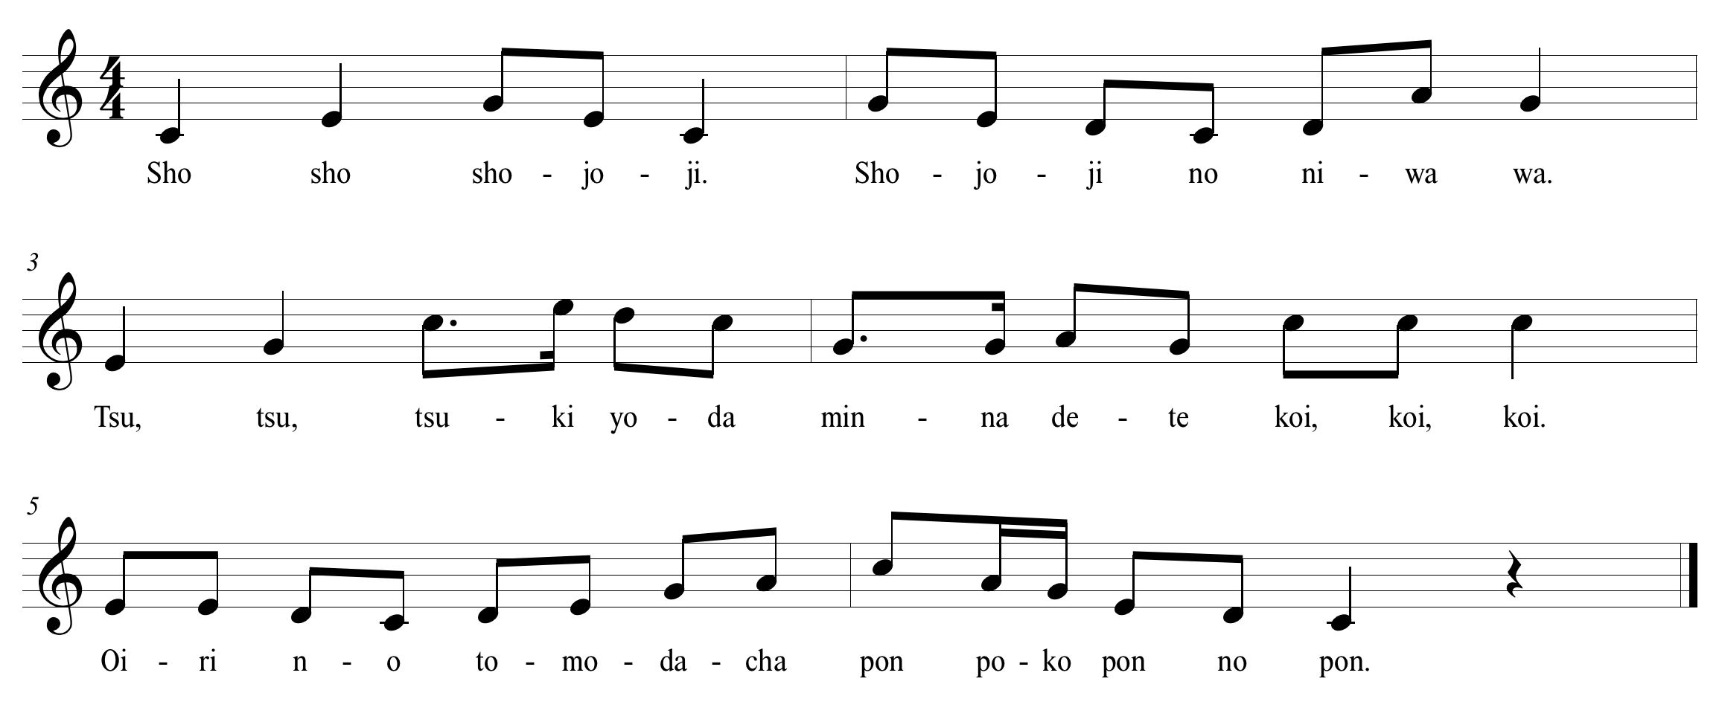

Chart 4:

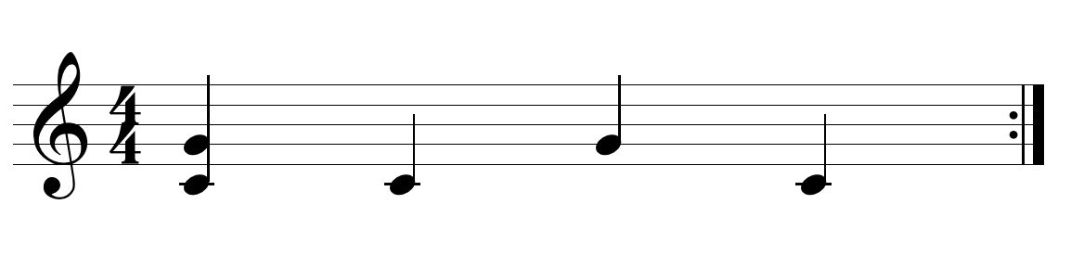

Chart 5:

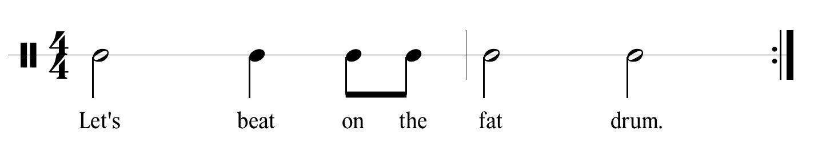

Macintosh HD:Users:Cathlyn:Desktop:Orff:Sho Jo Ji.pdf