*Name: Chet-Yeng Loong
*Grade Level: Grade 2
*State Core Music Standards (draft):
For example: Cr1.1, Cr 2.1, Cr. 3.1., 3.2, copy and paste the standard(s) here:

Figure out yourself . . .

*Prerequisites:
- Ta, ti-ti, Z
- Playing hand drums
- Partner songs/chants

*Objectives/Outcomes (no more than five) – for example, artistic skills/knowledge/contextual learning:

??

*Procedures:
Sequence/Time | Activity | Procedures | Materials
Day 1 | I like it when it’s hot | - Perform children the below chant with body percussion (I still need to find the source):  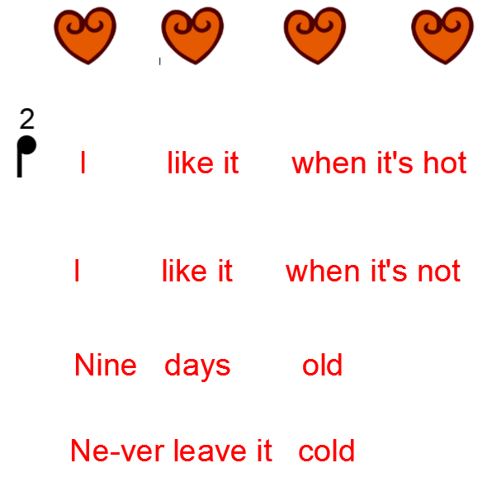  Stomp at: I, hot, not, Nine days old, cold.  Clap the rest of the words.  - Teach the chant phrase by phrase.  - Ask children just do the stomping parts.  - Ask children combine stomping and clapping sections.
Day 2 | I like it when it’s hot | - Teach children drumming down-up technique.  - Stomping parts – down; clapping – up.  - Give drums to children, teach them drumming while chanting.  - Go over the whole chant phrase by phrase.  - Take away the word, just play the drums.
Day 3 | Pease porridge hot & I like it when it’s hot | - Review Pease Porridge Hot and I like it.  - Divide class into two groups.  - One group sings Pease Porridge Hot and the other plays the drum while chanting I like it.  - Perform the whole piece with ABCBA form.  - A: Pease Porridge Hot; B: I like it (body percussion); C: Combine both; B: I like it (drum); A: Pease Porridge Hot.

Assessment.

Teacher’s reflection/talk:

??

