Kapolei Middle School
Cooperating Teacher: Kevin Morita
Period 3, 6th grade Introduction to Chorus
11:15am-12:05pm

Central Focus:
The central focus of this lesson is reviewing the basic rhythmic components of ta (quarter note), ta-a (half note), ta-di (eighth notes), and rest (quarter rest). The concepts will be reviewed visually via a Google Slides presentation, and musically by having students 4 echo 4 beat patterns involving said rhythmic components.

Objectives:
Students will be able to:
- Visually identify the following rhythms: ta, ta-a, ta-di, and rests
- Perform 4 beat patterns involving ta, ta-a, ta-di, and rests as echo

Time | Method | Materials
11:15-11:20am | - Take Attendance  - Address any tech issues  - Announcements | Infinite Campus
11:20-11:30am  (10 min) | Socio-Emotional Learning (SEL) Time  - What are 1-2 fun things you did over the weekend?  - Ask students questions, about where they did their thing  - Why was it fun?  - Who else was there?  It was good that you took some time to talk with the students, included Mr. Morita.  Thanks for asking Cody to sit up. | Google Meets
11:30am-11:40am  (10 min) | Review Ta, Ta-a, Ta-di, rest (Slide 1)  - Give 30 sec. To pull out notes  - Have 1 student to identify and demonstrate clapping for each rhythm. Ask a new student for each rhythm  - Ta (clap once)  - Ta-di (clap 2x per beat  - Ta-a (clap then slide hand away)  - Rest (pat shoulders)  I don’t know how long this group of students has learned music notations. Maybe just spend 5 min to review the notes. Or, use google assessment (I use HelloSMART link to interact) with the students and let them drag the notes to the right spots).  This teaching procedure is under the Remembering stage, under Bloom’s taxonomy, taking more time to “drill” the notes will not help. Instead, suggesting them to identify a series of notes will help them shift short-term memory to long-term memory.  - Have 1 student each identify how many beats each rhythm gets  - Ta (1 beat)  - Ta-di (2 sounds, 1 beat total)  - Ta-a (2 beats)  - Rest (1 beat of silence) | Google Slides  https://docs.google.com/presentation/d/1lqEyed_M2gVo7S8UwgEo6nasl8UWsklzX9xDdH1sTPI/edit?usp=sharing
11:40am-12:00pm  (20 min) | 4 Beat Patterns  - Have students identify the names of each rhythm in the pattern  - Ta ta ta-di ta  - I do, you do  - Demonstrate chanting the rhythm, then have students repeat back  - Repeat rhythm 2-3x  - Repeat steps 1-2 for the following rhythms  - Ta ta ta-a  - Ta-di ta ta-a  - Ta-a ta-di ta  - Ta ta rest ta  - Ta rest ta ta  - Ta rest ta ta-di  Instead of asking them to identify each note, maybe asking students to identify a series of notes would make more sense. Music is about a series of sounds, not just one note/sound. | Google Slides  https://docs.google.com/presentation/d/1lqEyed_M2gVo7S8UwgEo6nasl8UWsklzX9xDdH1sTPI/edit?usp=sharing
12:00-12:05pm  (5 min) | Closing  - Announcements and reminders  - Homework?

Notes from Kevin:

If students are ahead:
- Use 1 student as a model for others
  - Ex. Have Cody do a pattern, then ask Isaiah to do the same pattern as Cody
    - Lets students hear from others, gives students chance to hear the correct answer, and focus on executing
- Jump back to previous slides
  - See if students can remember on their own
  - Give chance to review, and still move on to new material
- Pick random slides
  - Similar to flash cards, pick random slide
  - Give students a few seconds to look at it, then clap and count it
- Echo patterns generated by teacher
  - Have students echo back, maybe have one student do after
Clapping is too loud
- Clap farther away from microphone

Next steps:
- Have 1 student create a pattern and perform it
  - Have other students try to echo it back
  - If it’s too long, then they can see what kind of limits they have

- 2 beats between modelling and having students go
  - Saves time

From Dr. Loong:

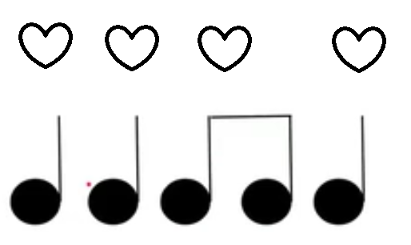
Sequence of questions:
- Remembering – what is the name of this note, how many beats does it carry -
placing beats in the chart (the students can visualize and identify it quickly).
- The second note – is it the same or different (Bloom’s – Understanding, raise a level higher). So, what is this note called?
- How about the 4th beat – same or different? When you asked them to identify the same note, you are also reviewing, but the notes are located at different beats in a 4*beat pattern.
- 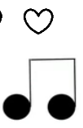 The 3rd beat in this pattern, is it the same or different? Do you remember what this is called (Remembering)? (If students do not remember, you tell them the answersand I believe these notes are coming in the next question).
- Who can clap this pattern? Who wants to try (Applying)? Instead of clapping for them, asked them to imitate, you should encourage them to try.

Basically, you stayed too long at the remembering stage of Bloom’s stage, you definitely can challenge them. I am also teaching 6-8 years old with the same rhythm online; I challenge them all the time.

2nd chart: Half-note:
- You did ask about the “same and different: here.
- I strongly encourage you to place the heart-beats on top of the beats. See below:
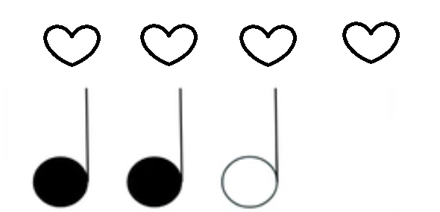
When you asked how many beats a ta-a carries, this will help the students to get the answer.
- Again, challenge the kids to clap the patterns (Applying).

3rd chart:
- Good, you asked the students to clap the patterns right away.
- Is there a way you can record students’ performance?
- And, try not to move your mouse too much.

Overall, the teaching is adequate. You constantly check the students about their participation and help the students to fix the mistakes. My two suggestions are to ask students high-level questions and avoid asking them to imitate too much. One way you can do this is, ask a student claps a pattern; you clap after; then ask the rest of the class whether both of you to clap the same or different patterns; this will raise the level to “Analyze.”

